**Exercise: Visualizing data by geographical location**

**Introduction**

By now, you have a deeper knowledge of how map visuals can be used effectively in Microsoft Power BI and how they add visual impact to reports. You have explored the essential concepts of map visuals such as **Shape maps**, **Choropleth maps**, **Azure maps** and **Filled maps** and experienced how they are used to generate regional insights and create geo hierarchies from your data.

In this exercise, you can apply this knowledge while creating an enhanced sales report for Adventure Works.

**Scenario**

Adventure Works sells its products globally, generating a large amount of sales data.  As a result, it is important to create more focused summary reports to help regional managers understand the information and predict trends in their own geographical regions. Adio, one of the regional sales managers in the United States, has requested such a report. As a data analyst and experienced report designer, you know that while Power BI offers a range of map visualization options, the **Shape map** visual is the appropriate choice because you will be focusing on data from only one country.

By completing this exercise, you will demonstrate your ability to:

* Review and format the data to be used in the map visualization.
* Create a **Shape map** visual in the Power BI report to display the sales data for specific US states.
* Format and configure the map appropriately using color coding and design perspectives.

**Instructions**

**Step 1: Download the Power BI project File**

Download and open the *Adventure Works Visualizing data by geographical location.pbix*. This file contains a single data table **Sales vs States** which contains two data fields: **Sales** and **States**.

[Adventure Works Visualizing data by geographical location](https://d3c33hcgiwev3.cloudfront.net/1VS2FLoSQn2v4Qs6jXYvmA_5bd350bed76d4bb7af3e4696e06b68e1_Adventure-Works-Sales-C6M2L2-Exercise-Visualizing-data-by-geographical-location.pbix?Expires=1712275200&Signature=CWR7u2dEe3oiUhIm0swQkouE9jAjLfxDCqpYaAxodM4NfPfEo64L7~ZAG4TnTQDpAMV-m9eACKKVfX7W~-DJd0G6heJS~De1iqGtrW7ZP6u-WyjL3WqjXPID5YJoEBiS1xgOA6u8dPCUqE3jUYhSExy~c2c3bsudiUJbOoYYyfw_&Key-Pair-Id=APKAJLTNE6QMUY6HBC5A" \t "_blank)

[PBIX File](https://d3c33hcgiwev3.cloudfront.net/1VS2FLoSQn2v4Qs6jXYvmA_5bd350bed76d4bb7af3e4696e06b68e1_Adventure-Works-Sales-C6M2L2-Exercise-Visualizing-data-by-geographical-location.pbix?Expires=1712275200&Signature=CWR7u2dEe3oiUhIm0swQkouE9jAjLfxDCqpYaAxodM4NfPfEo64L7~ZAG4TnTQDpAMV-m9eACKKVfX7W~-DJd0G6heJS~De1iqGtrW7ZP6u-WyjL3WqjXPID5YJoEBiS1xgOA6u8dPCUqE3jUYhSExy~c2c3bsudiUJbOoYYyfw_&Key-Pair-Id=APKAJLTNE6QMUY6HBC5A" \t "_blank)

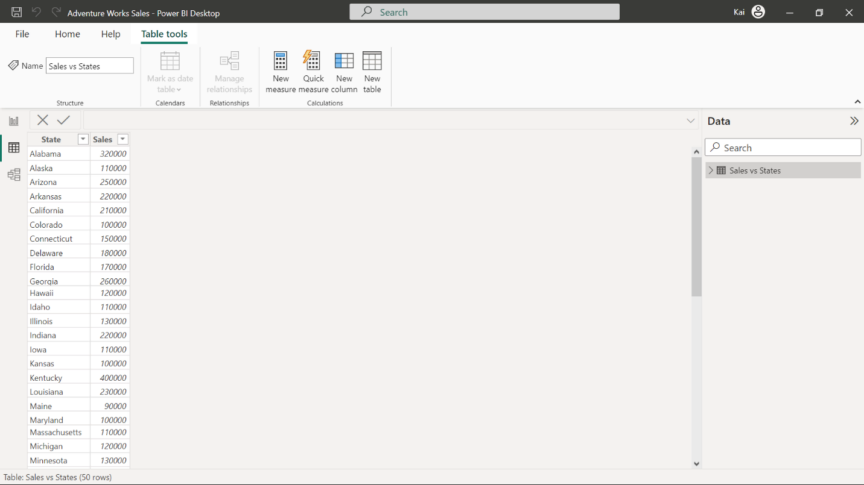

**Step 2: Review and format the data type**

1. Review the data in the two data files. Assess the field categories and types and adjust the format where the data type is not appropriate for use in map visualization.

**Tip:** You review and change the data type from the **Column Tools** tab in Power BI desktop.

**Step 3: Create a Shape map visual to present the sales data**

1. Create a **Shape map** visual. In the **Data pane** select and add the appropriate data fields from the data pane to the map visual fields..
2. Resize the map visual to fill the report canvas.

**Tip:** The **Visualization pane** provides you with all the information you need to build the map visual.

**Step 4: Format and configure the map visual**

1. Apply the **Accessible city park** theme. Format the color scheme of the map to create a color coding that represents the sales trend across the states.
2. Configure and validate the zoom control of the map so the report users can manually select a specific region in the map.
3. Format the title and tooltip to create an easy-to-understand experience of the visualization.

**Tip:** You can access the formatting options in the **Visual** and **General** tabs of the **Visualization pane**.

**Step 5: Save the Power BI project**

1. Save the amended Power BI report locally on your computer.

**Conclusion**

The **Shape map** visualization that you have successfully created and configured, will display the sales data for the United States in a layered way. It will allow report users such as Adio to view overall sales information while also being able to drill-down to more focused regional analysis.

**Exemplar: Visualizing data by geographical location**

**Introduction**

In the exercise Visualizing data by geographical location, you were asked to create and format a map visual in Microsoft Power BI using Adventure Works sales data.

Your tasks in the exercise include:

* Review and format the data types and categories in the data to be used in the map visualization.
* Create a **Shape map** visual in Microsoft Power BI desktop to display the sales data for the United States.
* Configure and format the map visual to reflect the sales trend across the United States.

This reading provides you with a step-by-step guide for completing these tasks. It also includes screenshots that you can compare against your work.

You can also refer to the video *Shape map visuals.*

**Step 1: Download the Power BI project file**

Download and open the *Adventure Works Visualizing data by geographical location.pbix*.

[Adventure Works Visualizing data by geographical location](https://d3c33hcgiwev3.cloudfront.net/1VS2FLoSQn2v4Qs6jXYvmA_5bd350bed76d4bb7af3e4696e06b68e1_Adventure-Works-Sales-C6M2L2-Exercise-Visualizing-data-by-geographical-location.pbix?Expires=1712275200&Signature=CWR7u2dEe3oiUhIm0swQkouE9jAjLfxDCqpYaAxodM4NfPfEo64L7~ZAG4TnTQDpAMV-m9eACKKVfX7W~-DJd0G6heJS~De1iqGtrW7ZP6u-WyjL3WqjXPID5YJoEBiS1xgOA6u8dPCUqE3jUYhSExy~c2c3bsudiUJbOoYYyfw_&Key-Pair-Id=APKAJLTNE6QMUY6HBC5A" \t "_blank)

[PBIX File](https://d3c33hcgiwev3.cloudfront.net/1VS2FLoSQn2v4Qs6jXYvmA_5bd350bed76d4bb7af3e4696e06b68e1_Adventure-Works-Sales-C6M2L2-Exercise-Visualizing-data-by-geographical-location.pbix?Expires=1712275200&Signature=CWR7u2dEe3oiUhIm0swQkouE9jAjLfxDCqpYaAxodM4NfPfEo64L7~ZAG4TnTQDpAMV-m9eACKKVfX7W~-DJd0G6heJS~De1iqGtrW7ZP6u-WyjL3WqjXPID5YJoEBiS1xgOA6u8dPCUqE3jUYhSExy~c2c3bsudiUJbOoYYyfw_&Key-Pair-Id=APKAJLTNE6QMUY6HBC5A" \t "_blank)

The data model in this file contains one table, which is called **Sales vs States**. This table contains two data fields titled **Sales** and **State**.



**Step 2: Review and format the data type and category**

Both of the fields in the **Sales vs States** tables are in the wrong format. The **State** field is formatted as text with a data category of **Uncategorized**. When the data in a column is to be used in a map visualization, it is advisable to categorize the geographical data more appropriately as longitude, latitude, country, and so on. Change the category of the **State** field to **State or Province**.

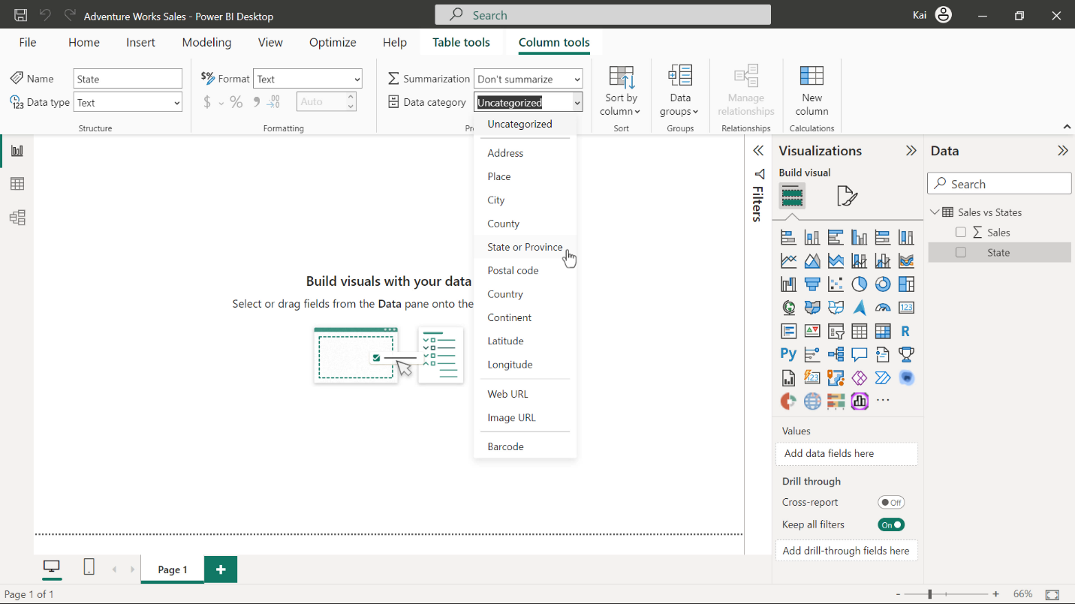

The data type of the **Sales** field is initially set to **Whole number**. As these figures represent sales, change the data type to **Currency**.

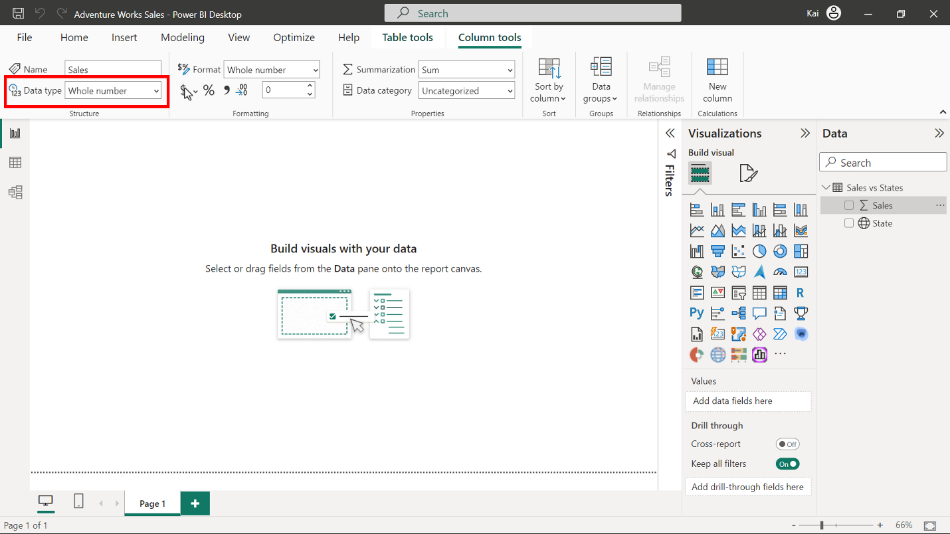

**Step 3: Create a Shape map visual to present the sales data.**

1. Select the **Shape map** visual in the **Visualization pane** to add it to the canvas. Drag the **State** field to the **Location** well of the **Shape map** visual. Add the **Sales** field to the **Color saturation** well of the **Shape map** visual.

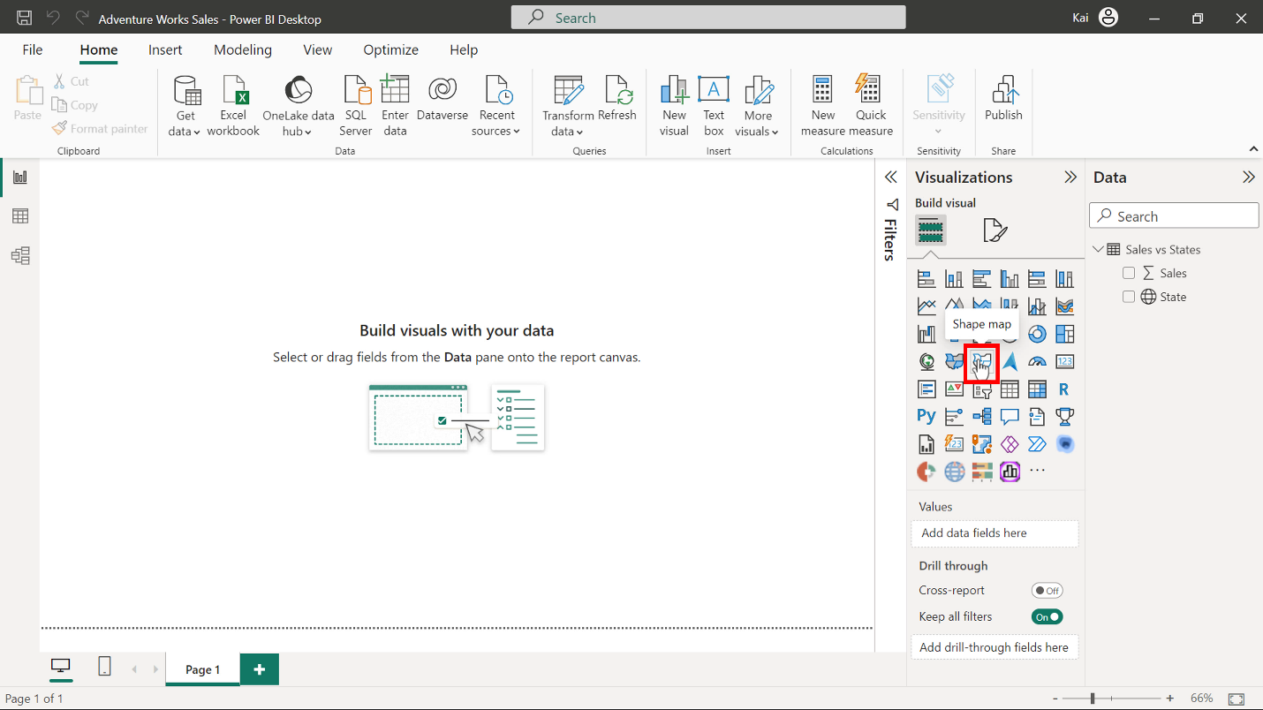

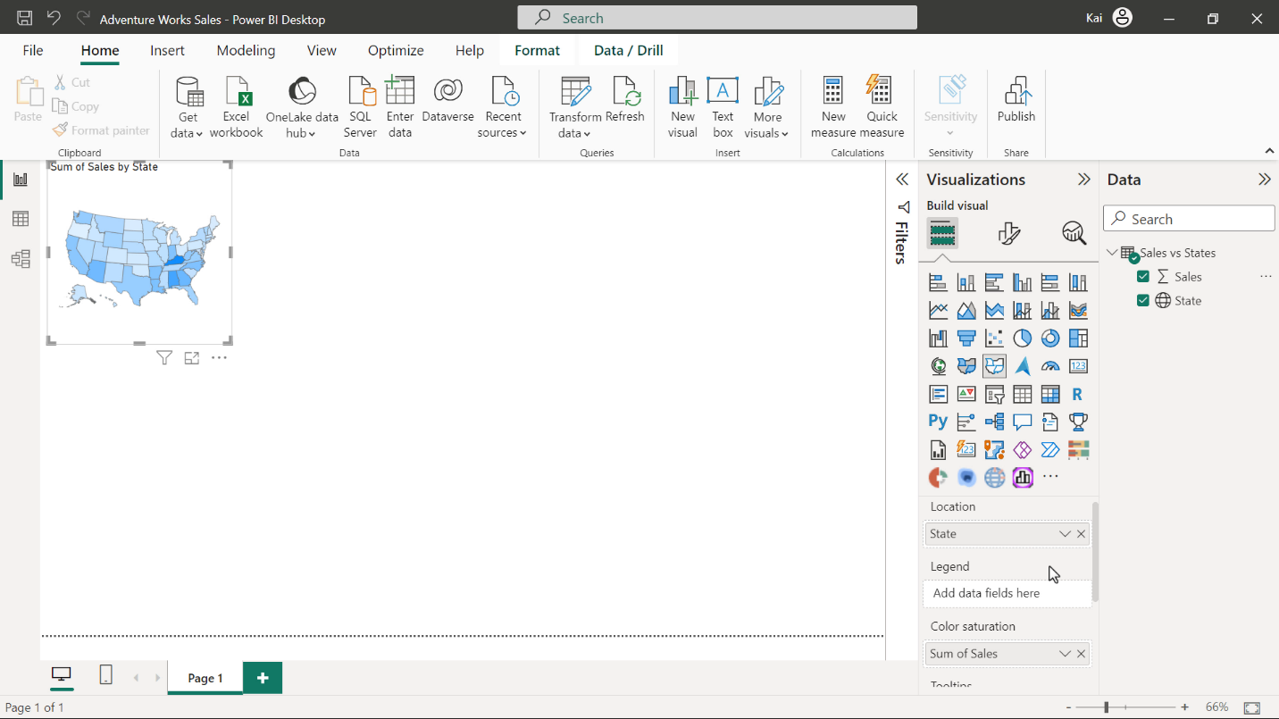

2. Resize the map visual to fill the report canvas by dragging any side of the image. Alternatively, in the **Format visual** section of the **Visualizations pane,** you can select **General** and then expand the **Properties** options**.** In this area, you can manually define the height and width of the visual.

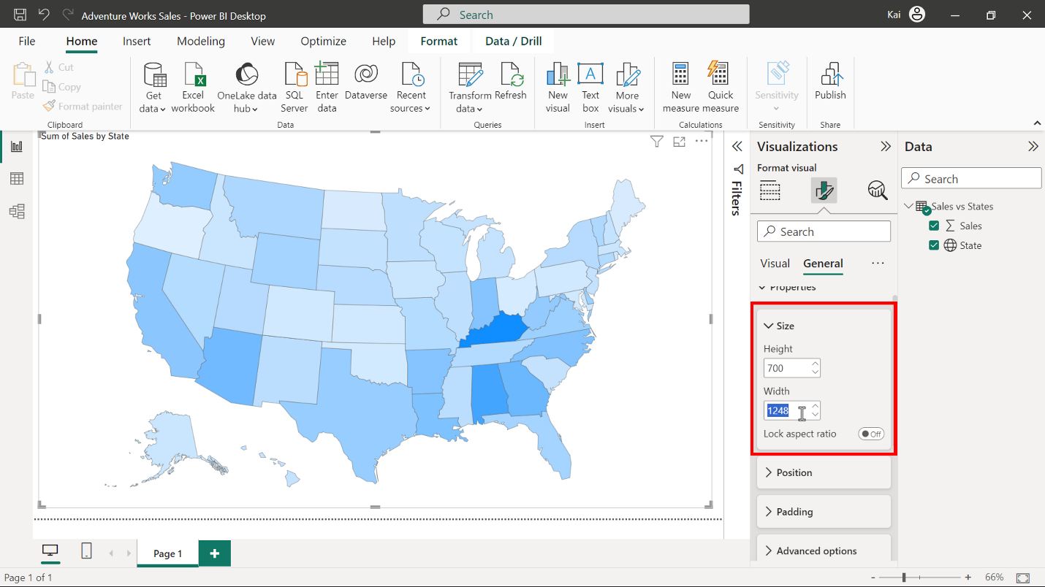

**Step 4: Format and configure the map visual**

1. Apply the **Accessible city park** theme by selecting it from the View ribbon. This will improve the accessibility of the report.

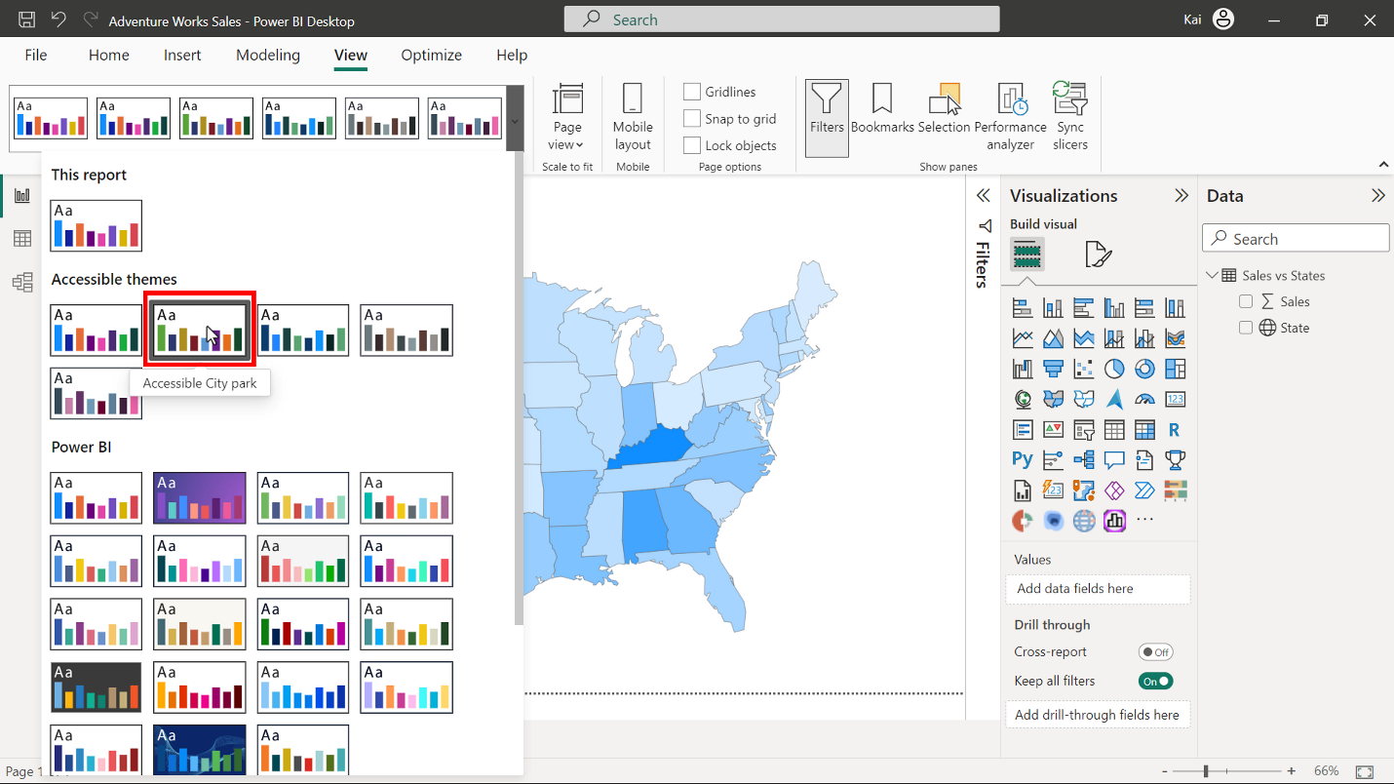

You can customize the colors used in the visualization by going to the **Fill colors** option in the **Format visual** pane. There are currently, two choices of coloring for a **Shape map** visual. The first applies two colors for maximum and minimum values. The second option allows you to define a color for a center point and then provides gradient colors for the other values.  You can use any of the three theme colors. You can also apply borders to create greater separation of the states.

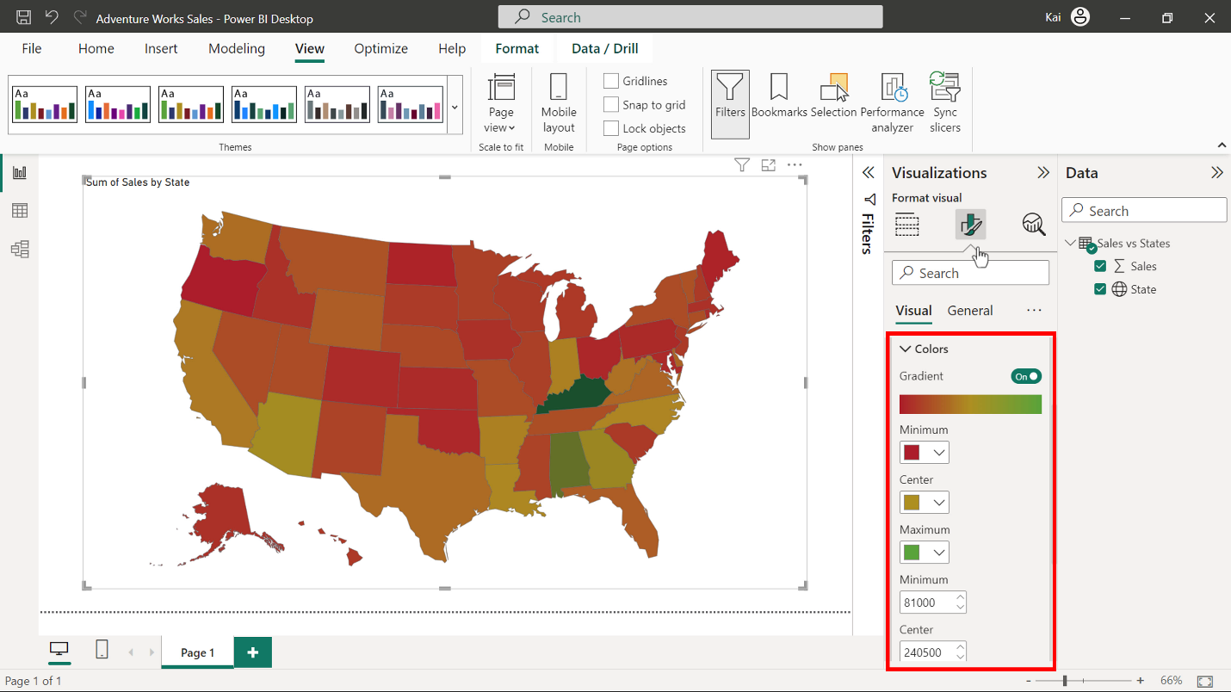

2. One of the benefits of the map is that users can manually select a specific region to view data relating to it. To configure this option, you need to set the zoom control on the map. Select **Map settings** and then expand the **Zoom option**. Three choices are available, **Auto zoom**,**Zoom on selection**, and **Manual zoom**.  To correctly set the zoom for this map visual, move the toggle button for **Zoom on selection** and **Manual zoom** to the on position.

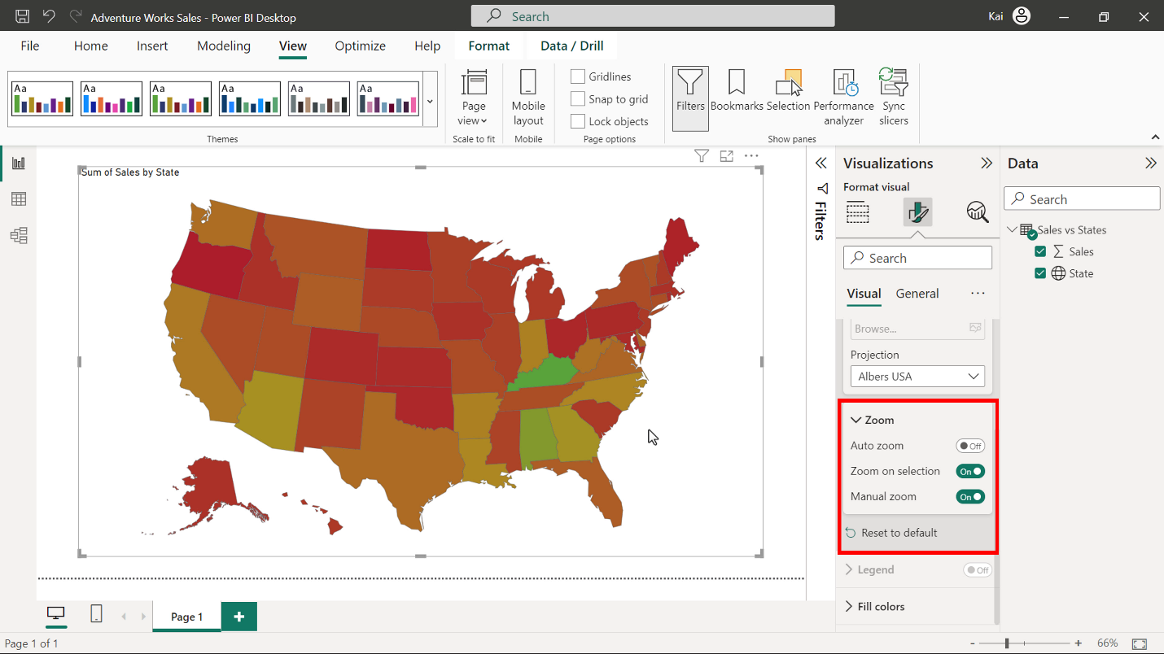

You can confirm that the zoom feature is functioning correctly by selecting any state. This will make the visual zoom in on that area.

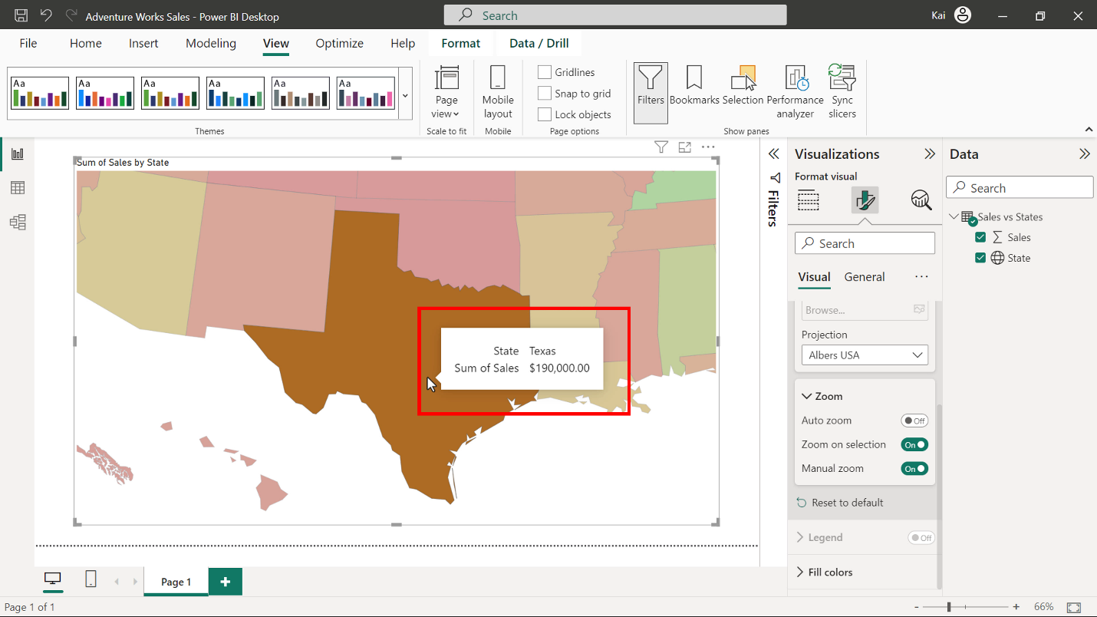

3. Change the wording and appearance of the title in the **General** tab of **Visualizations pane**. There is also a setting in this tab that allows you to change the text size, color, and background color of the tooltip so that it matches design or brand requirements.

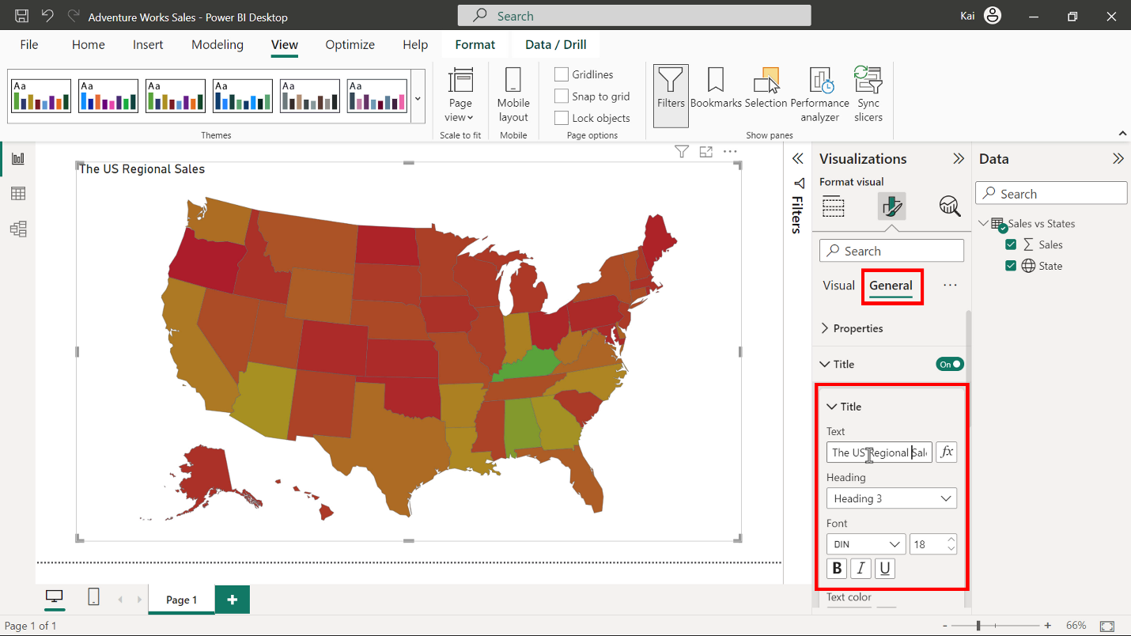

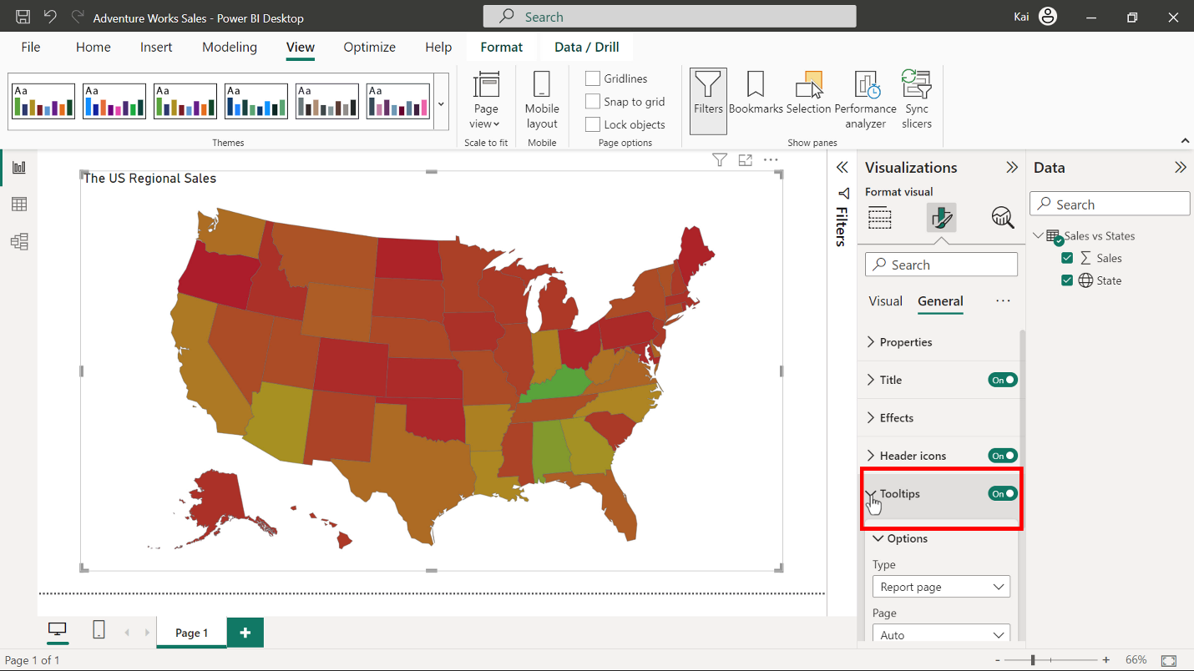

**Step 5: Save the Power BI project**

To save the project, open the **File** menu, select **Save As,** and provide an appropriate name for the project along with a path to the folder on your computer.

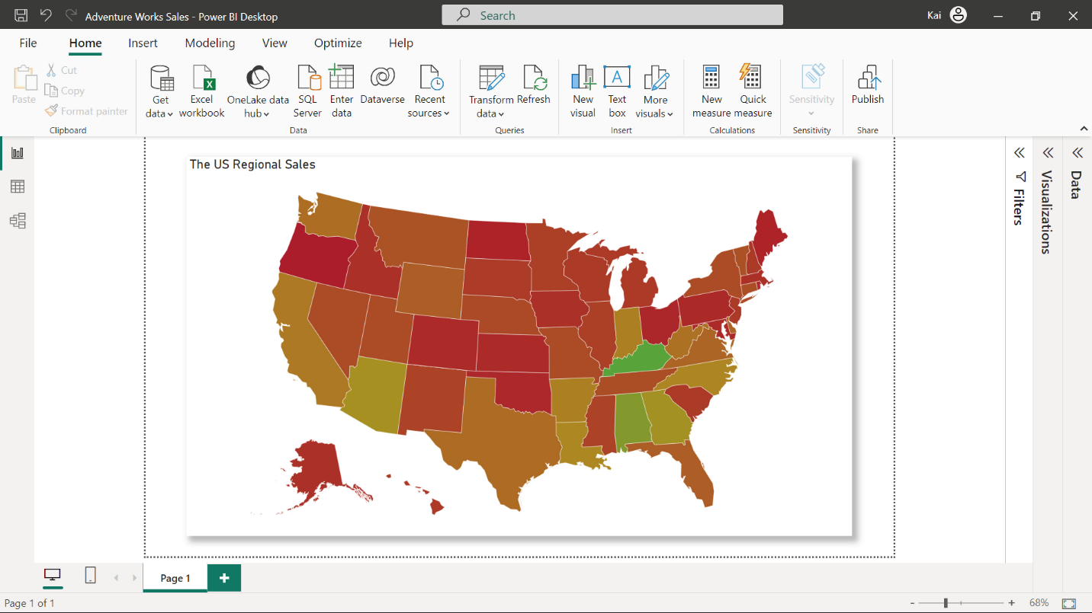

**Conclusion**

With these steps, you have successfully created and formatted a shape map visual to display the Adventure Works’ sales data for the United States. Regional managers in Adventure Works can now have better insight into patterns and trends in regional sales performance color coding in the map.